# spring-rest-handson

**Hello World RESTful Web Service**   
  
Write a REST service in the spring learn application created earlier, that returns the text "Hello World!!" using Spring Web Framework. Refer details below:  
**Method:** GET  
**URL:** /hello  
**Controller:** com.cognizant.spring-learn.controller.HelloController  
**Method Signature:** public String sayHello()  
**Method Implementation:** return hard coded string "Hello World!!"  
**Sample Request**: http://localhost:8083/hello  
**Sample Response:** Hello World!!   
-------------------------------------------------------------------------------------------------------------------

**SOLUTION**

Open previously made springlearnapplication .

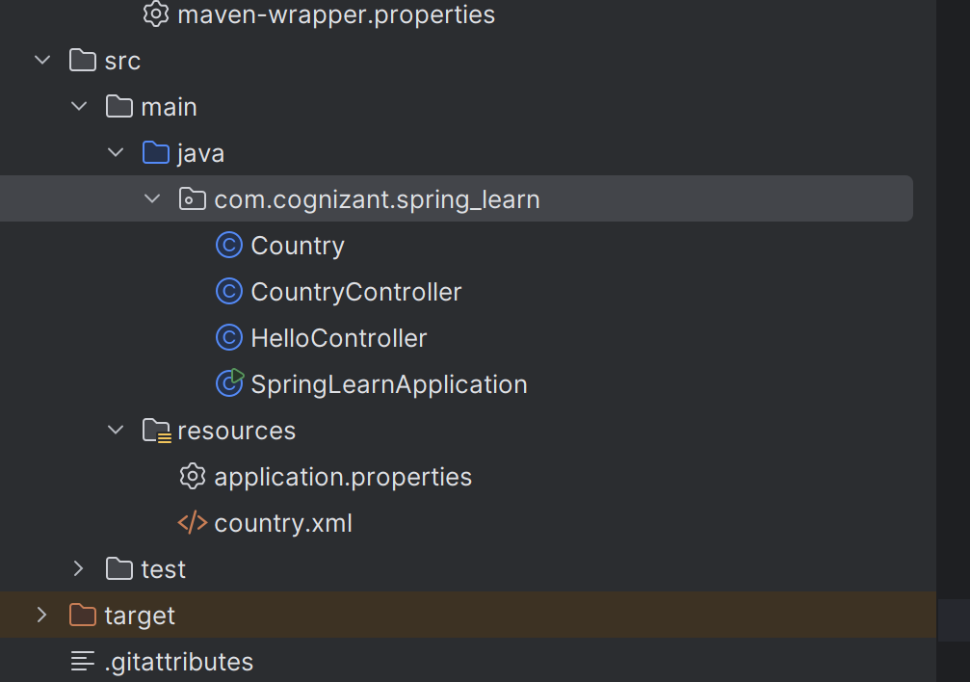

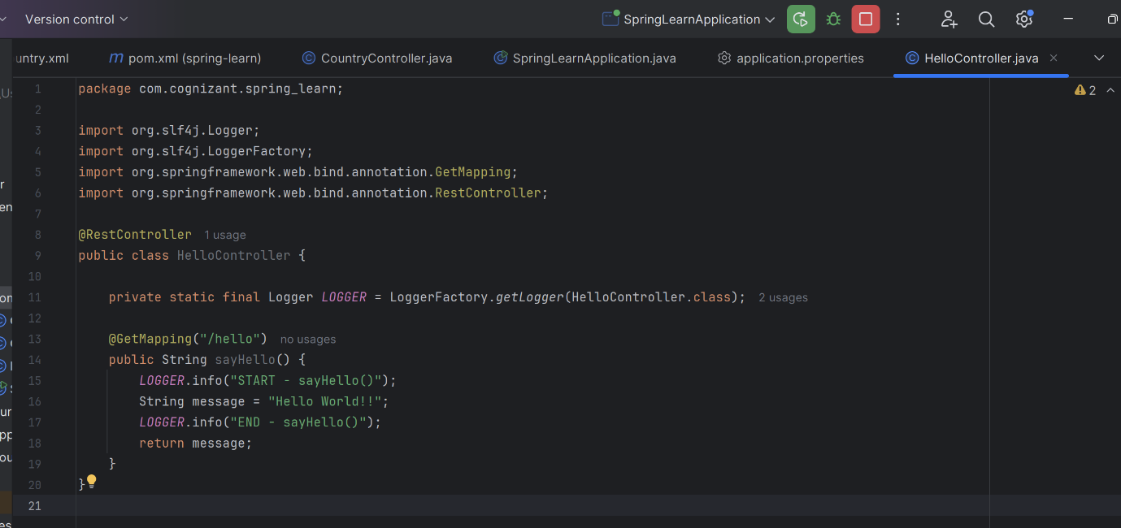

**http://localhost:8083/hello**

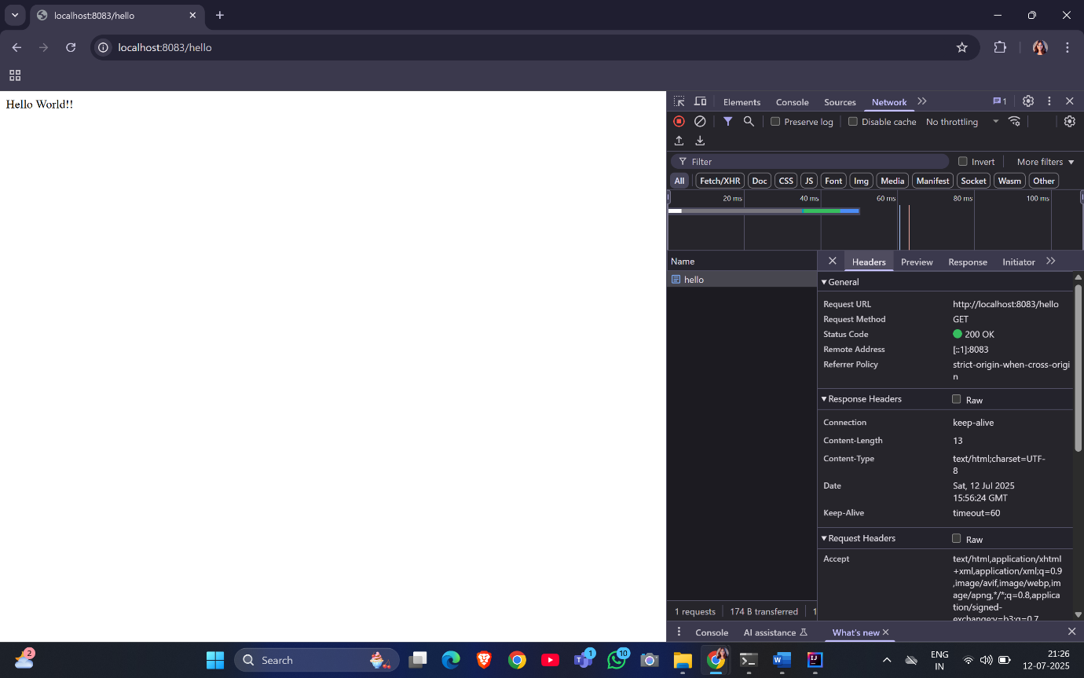

**REST - Country Web Service**

Write a REST service that returns India country details in the earlier created spring learn application.

URL: /country

Controller: com.cognizant.spring-learn.controller.CountryController

Method Annotation: @RequestMapping

Method Name: getCountryIndia()

Method Implementation: Load India bean from spring xml configuration and return

Sample Request: http://localhost:8083/country

Sample Response:

{

"code": "IN",

"name": "India"

}-----------------------------------------------------------------------------------------------------------------------------------------------

**SOLUTION**

Open the previously made SpringLearnApplication.

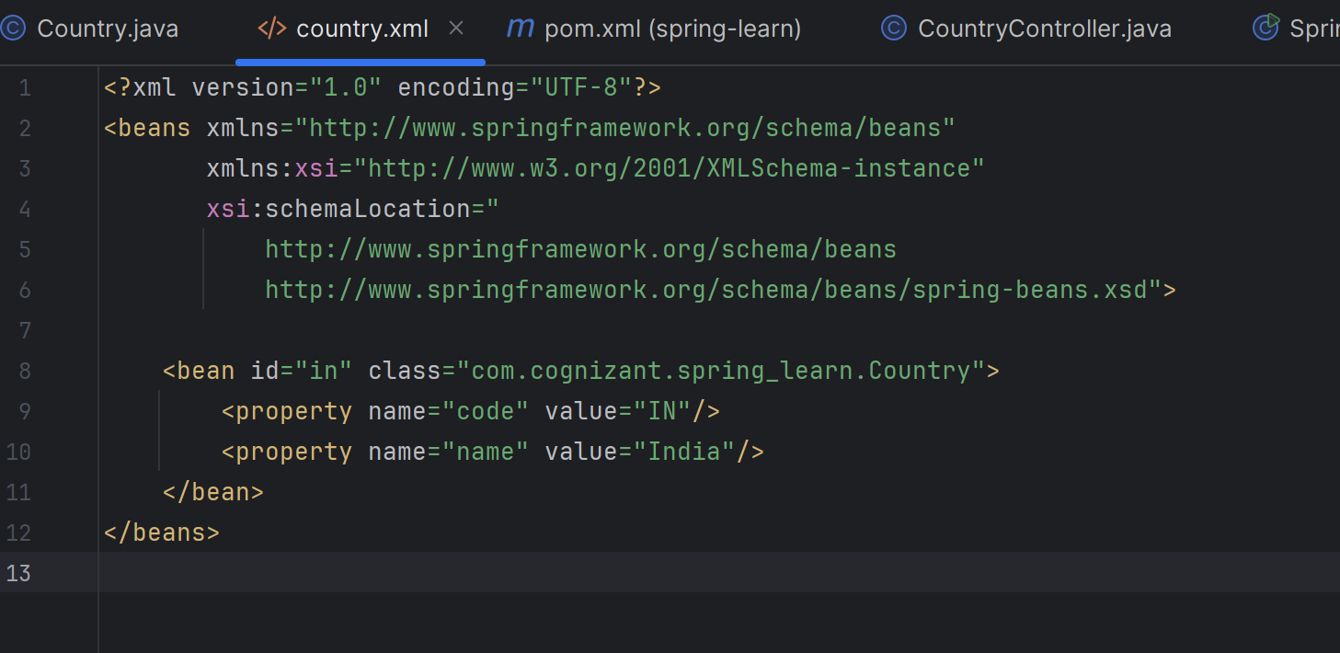

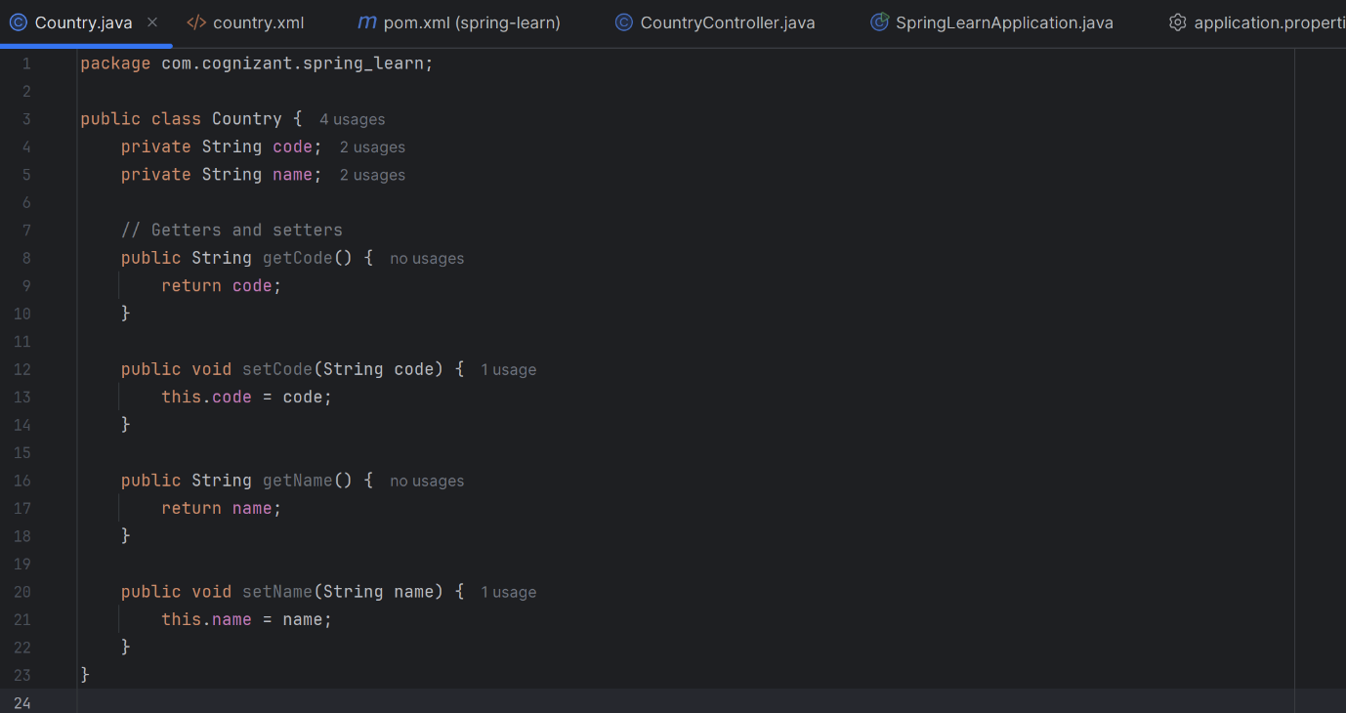

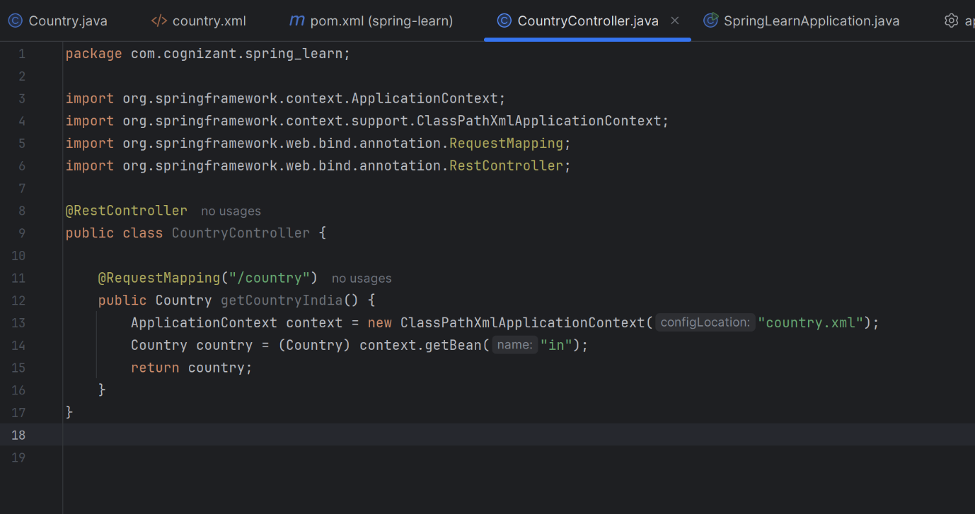

**OUTPUT**

http://localhost:8083/country

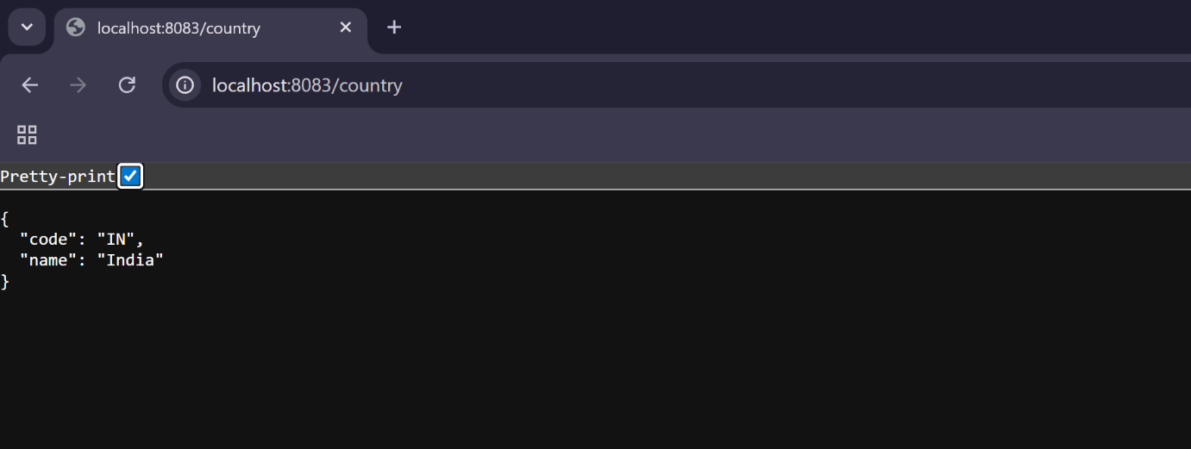

**REST - Get country based on country code**Write a REST service that returns a specific country based on country code. The country code should be case insensitive.  
**Controller**: com.cognizant.spring-learn.controller.CountryController  
**Method Annotation:** @GetMapping("/countries/{code}")  
**Method Name**: getCountry(String code)  
**Method Implemetation**: Invoke countryService.getCountry(code)   
**Service Method:**com.cognizant.spring-learn.service.CountryService.getCountry(String code)  
**Service Method Implementation**:

* Get the country code using @PathVariable
* Get country list from country.xml
* Iterate through the country list
* Make a case insensitive matching of country code and return the country.
* Lambda expression can also be used instead of iterating the country list

**Sample Request**: http://localhost:8083/country/in  
**Sample Response**:

{

  "code": "IN",

  "name": "India"

}

**SOLUTION**

Open the previously made SpringLearnApplication.

Update country.xml.

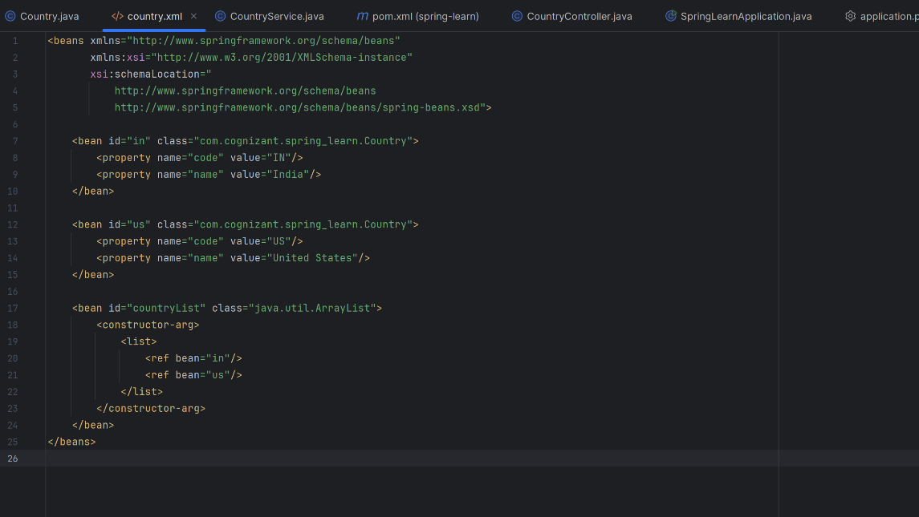

**src/main/java/com/cognizant/spring_learn/service/CountryService.java**

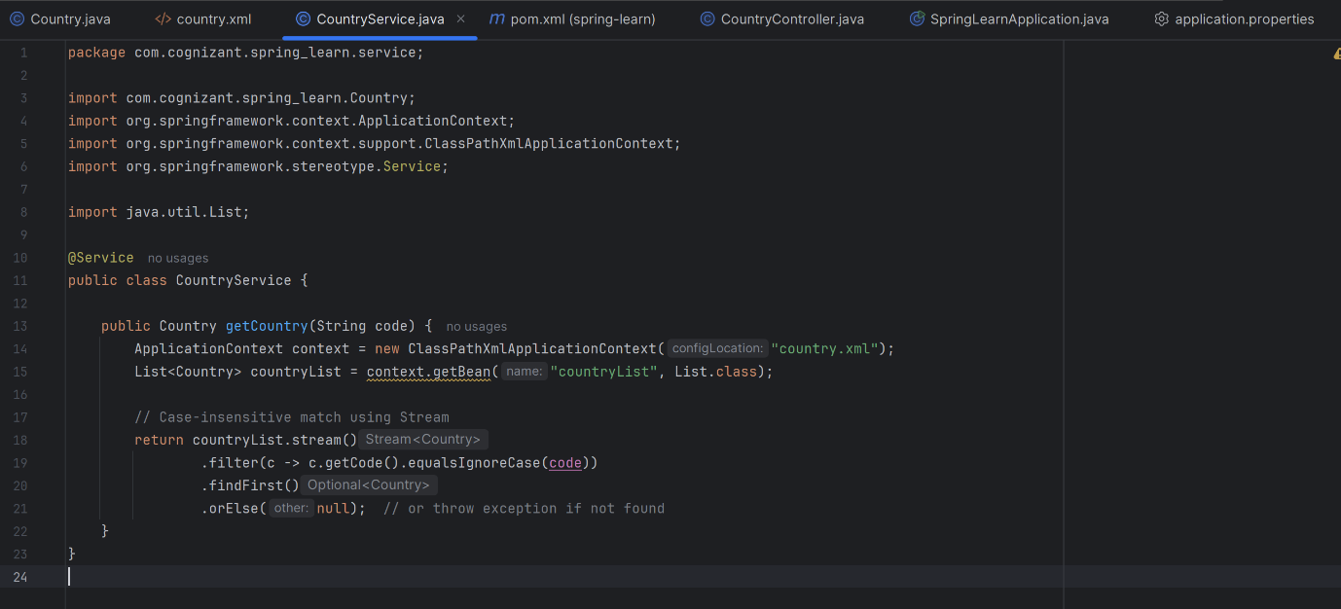

**Update countrycontroller**

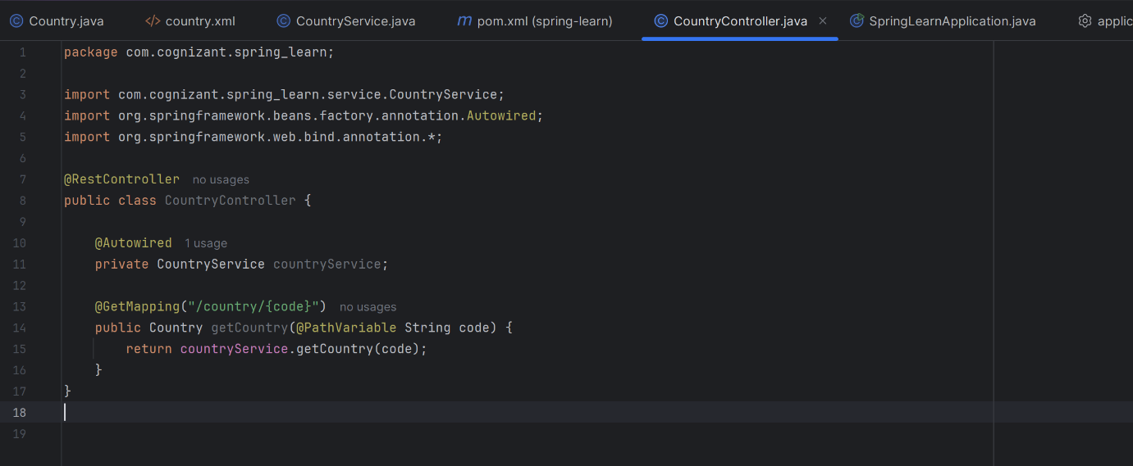

**OUTPUT**

[**http://localhost:8083/country/in**](http://localhost:8083/country/in)

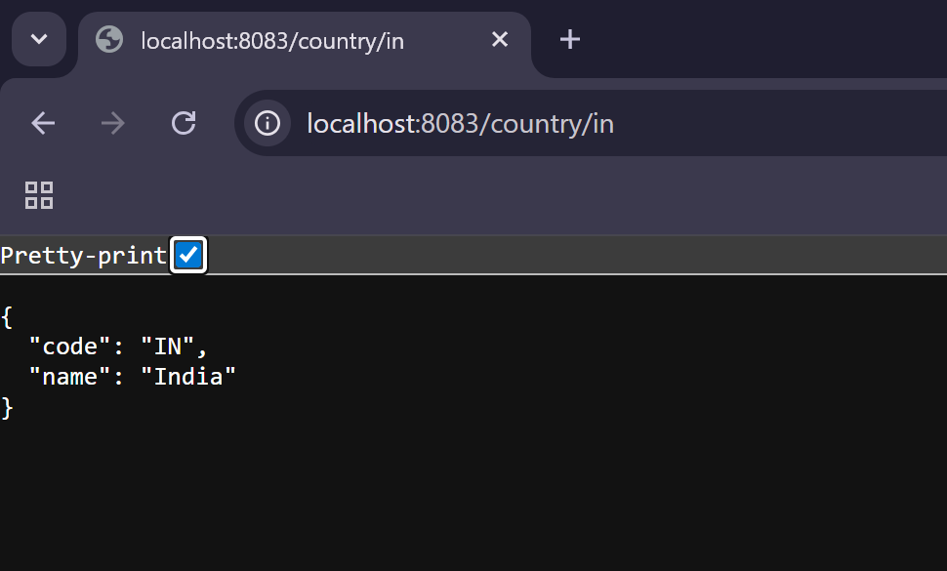

[**http://localhost:8083/country/us**](http://localhost:8083/country/us)



